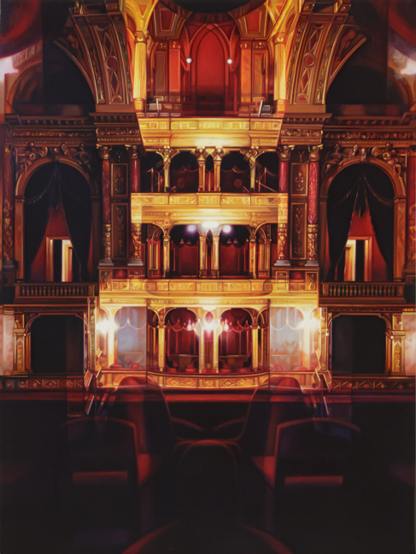
FOR IMMEDIATE RELEASE
Gallery Exhibition Schedule

Patti OLEON: Somewhere Else
November 8 – December 22, 2018

The oil paintings of Patti OLEON are highly representational depictions of period interiors, gathered during recent travels to Budapest, Prague, Venice, Berlin, and Istanbul, yet, like a stage set before the opening of a play, these interiors are resolutely devoid of human habitation. Highly detailed, yet unfamiliar and unplaceable, her depictions of interiors incorporate the distortions resulting from photo-documentation with a hand-held camera, using available light, and shallow depth of field. She composes structures and intersections of light and form from sections of these spaces, and then faithfully paints, using old master techniques, what the camera records, including any oddities of reflected light, seeking the edge between realism and illusion, the tension between the known and the unidentifiable. Pervasive warm light creates an ambiguous, sensuous skin that contradicts the motionless, powerful void. The entire room becomes a still life, with a relationship between time and image echoing a Proustian sensibility.
Opera, 2018, oil on hardwood wood panel
48 x 36 inches

Oleon's paintings unsettle us, and yet sustain our interest . . . Opera upsets reality by symmetrically perfecting it, achieving an ideal in décor at the expense of habitability. We literally do not know where we stand relative to the image. The more that we accept what our eyes see, the more that our bodies feel ghostly.

Given these complex dynamics of time and space—not to mention her preferred subjects and methods—Oleon's art has as much in common with avant-garde cinema as it does with contemporary painting. Her interiors occupy a mental space equivalent to Last Year in Marienbad, in which both time and space operate convincingly, disconcertingly, despite internal inconsistencies: Dialogue repeats in disconnected scenes, set within a chateau that is a filmic composite of multiple unrelated palaces. Like Marienbad, paintings such as Opera and The Met IV persuade us to suspend disbelief because our psychological states are not strictly reasonable, and our psyches are inherently more real to us than reality.
Patti Oleon's great accomplishment is not that she deceives us with her paintings, but that she lets us see ourselves being deceived. She reveals that our reality is our invention.

Modernism is proud to present its seventh one-person exhibition of paintings Patti OLEON. Oleon received both her B.A. and M.F.A from UCLA, from which she graduated Phi Beta Kappa and summa cum laude. She has been the recipient of numerous awards and grants, including the Guggenheim Foundation, Pollock Krasner Foundation Grant (twice), the Adolph and Esther Gottlieb Foundation Grant, Fulbright/DAAD Fellowship, Ford Foundation Grant, and an Ingram Merrill Foundation Grant.

The public is cordially invited to attend an opening reception on Thursday, November 8th, from 5:30-8PM.

FOR FURTHER INFORMATION CALL: 415/541-0461 / FAX: 415/541-0425, OR EMAIL TO: INFO@MODERNISMINC.COM.

HI-RES IMAGES AVAILABLE ON REQUEST.

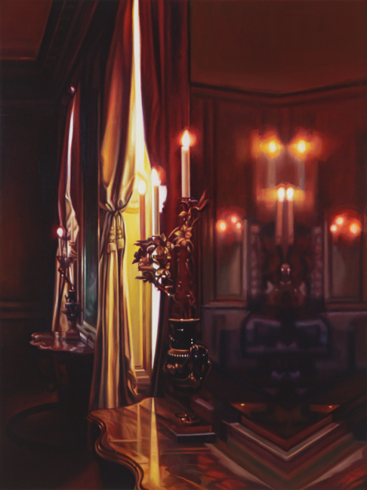

The Met IV, 2018
oil on hardwood panel
24 x 18 inches

