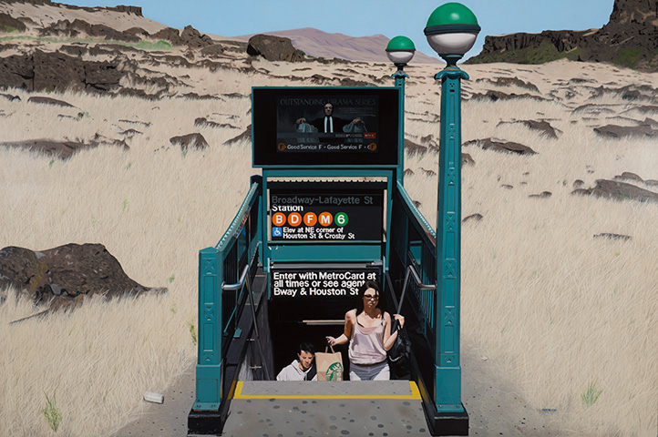
FOR IMMEDIATE RELEASE
Gallery Exhibition Schedule

Seth TANE: Trading Places
May 10 – June 30, 2018

Several years ago, Seth Tane hopped a barbed wire fence off State Route 14 near Dallesport, Washington, searching for just the right place to site a subway station. Surveying the rocky landscape, he took dozens of photographs, all of which he scrutinized back at his Portland studio. The daylight in one of the pictures perfectly matched the angle of the sun in another photo he'd once taken of a subway stop in Manhattan. Seamlessly blending the disparate images into a single scene, he created a large painting in which New Yorkers appear to emerge from underground into a desolate stretch of the Pacific Northwest.
Lost Stop, 2013, oil on panel, 48 x 72 inches

Over a four-decade career dedicated to urban and rural landscape painting, Tane often juxtaposes places he's been. Trading Places, his first solo exhibition at Modernism Gallery, explores this theme from multiple angles, presenting several of his "Subway Surrealism" paintings together with depictions of locations ranging from Fossil, Oregon to San Francisco's Chinatown.

Highly accomplished as a realist painter in the tradition of Edward Hopper and John Register, Tane portrays his subjects in meticulous detail, motivated by an interest in sharing what he's encountered. "I'm after causing the 'experience' of these locations to re-occur for the viewer," he says. To achieve that feat, he photographs places extensively, composing his final work from details captured in many different frames.

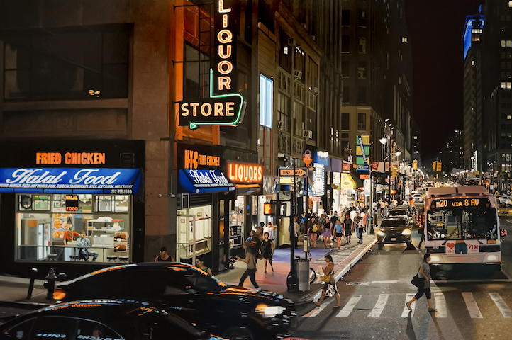
For instance, the monumental painting titled 8th Avenue began with multiple excursions to West 39th Street and 8th Avenue in Manhattan, an intersection that attracted him because it had "the right amount of visual texture". In order to take photographs from a high vantage point while walking through traffic, Tane mounted his camera on a tall pole, operating the shutter by remote control. Back in his studio, he selected and organized images into a single composition, studying details on his digital tablet while he created the 48" x 72" underpainting. Over three months, he applied layer after layer of pigment and glaze, paying particular attention to signage – a preoccupation he shares with Robert Cottingham and Ed Ruscha – as well as the complex interactions of urban artificial light.
8th Avenue, 2018, oil on panel, 48 x 72 inches

Tane considers this process to be equal parts observation and invention. "Sometimes an area begins as mere blobs of color," he says. "As I work it up, a face emerges, and even later on a glint in an eye reveals the direction of a gaze, and this triggers a memory of the moment when I first saw the scene."

And he has found that those memories are often all that remain after a painting is finished. "Many of the locations I've chosen to paint change shortly after my capturing the images," he says. "Signs are altered or removed, buildings are torn down and replaced, and I've unwittingly created an historic record."

These paintings also contain traces of Tane's personal history. Born in New York and now living in the Pacific Northwest (and a frequent traveler throughout his life), Tane says he's "always seeking the disruptive sense of being in two places at once." One of his most recent works, Fossil, Oregon, embodies this idea through the combination of natural and manmade attributes. "This expansive vista is seemingly remote from cities," he explains. "In fact it's connected to them in many ways, including a riot of information flowing down those thin wires overhead and beamed in from satellites."

The "Subway Surrealism" series makes explicit what is implied in his Oregon landscape. Inspired by the Surrealist paradoxes conjured by Rene Magritte – while also referencing the Alaskan subway terminal Buster Keaton emerges from in the opening scene of The Frozen North – paintings such as Lost Stop take the theme of dislocation to the furthest extreme.

Simultaneously they hold out the possibility of integrating disparate experiences into a single narrative. "We begin our journeys alone and together, flowing from buildings to streets and then through turnstiles that lead to the trains, riding in all our moods, in every season or time of day and night to our next stops," says Tane. "These paintings are frames in a dynamic cross section of the bustle and tumult of our daily travels."

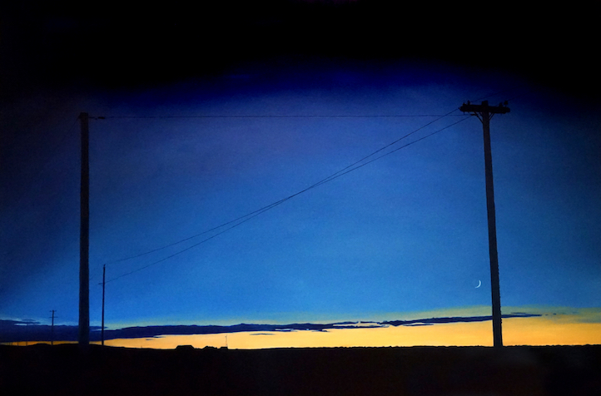
Modernism is pleased to present our
first exhibition of paintings by Seth TANE.

The public is cordially invited to attend an opening reception on Thursday, May 10th, from 5:30-8PM.

FOR FURTHER INFORMATION CALL:
415/541-0461 / FAX: 415/541-0425, OR
EMAIL TO: INFO@MODERNISMINC.COM.

HI-RES IMAGES AVAILABLE ON REQUEST.

Fossil, Oregon, 2018, oil on panel, 48 x 72 inches

